**SOFTWARE ENGINEERING**

**(IT-314)**

**EVENT PLANNER APPLICATION**

Low Level Design Document

Version 1.0

**Team no: 14**

**Instructor: Prof. Asim Banerjee**

**Team Mentor: K Hemantha**

**Date: 31 March, 2016**

**Team Members**

|  |  |  |
| --- | --- | --- |
| **S.No** | **Name** | **ID** |
| 1. | Patel Yash | 201301008 |
| 2. | Patel Tej Naginbhai | 201301018 |
| 3. | Anavadiya Yash Kumar | 201301052 |
| 4. | Chauhan Dwimitra Dharmendra | 201301079 |
| 5. | Rahul Shashank Saranjame (Team Leader) | 201301101 |
| 6. | Fatnani Varun Kumarbhai | 201301152 |
| 7. | Nikita Jain | 201301155 |
| 8. | Karri Kiran Satish Reddy | 201301168 |
| 9. | Raman Kumar Douchaniya | 201301202 |

**Version History**

|  |  |  |
| --- | --- | --- |
| **Date** | **Version no.** | **Authors** |
| 31/03/2016 | 1.0 | Kiran Reddy |

Design Overview :

Activity Diagram :

Activity Diagram is basically a flowchart to represent the flow from one activity to another activity .The activity can be described as an operation of the system.So the control is drawn from one operation to another.This flow can be sequential,branched or concurrent.

The basic purposes of activity diagrams is the dynamic behavior of the system.Other diagrams are used to show the message flow from one object to another but activity diagram is used to show message flow from one activity to another.Activity is a particular operation of the system.It doesnot show any message flow from one activity to another.

Login

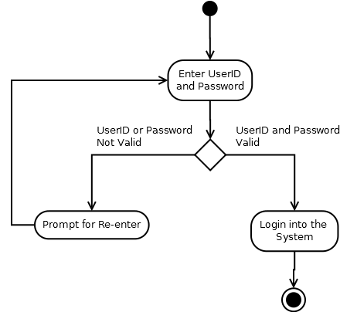

Registration

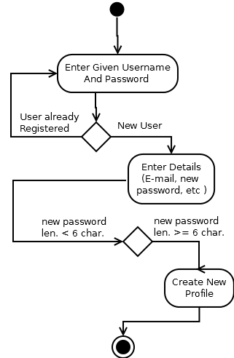

CreateEvent

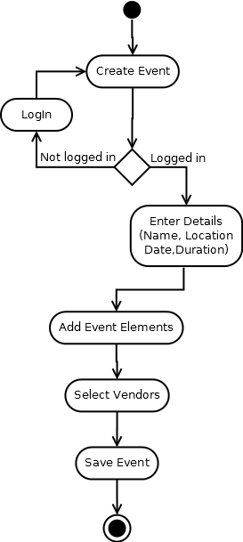

DeleteEvent

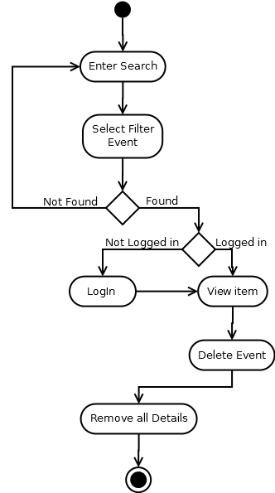

Edit Event

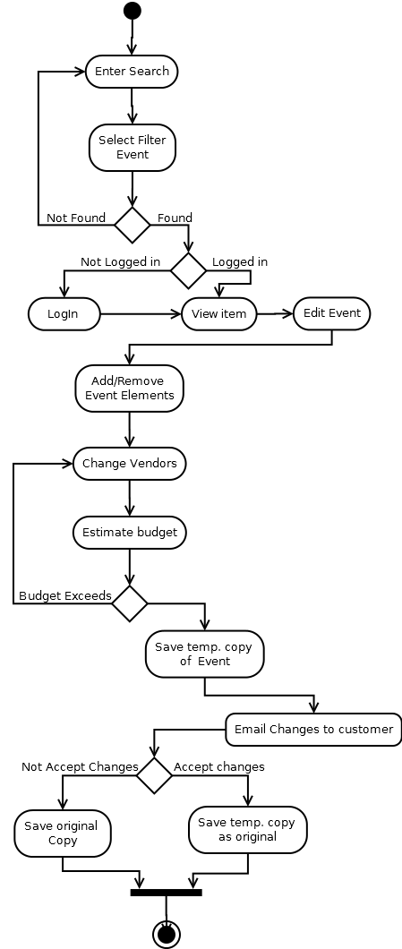

Forgot Password

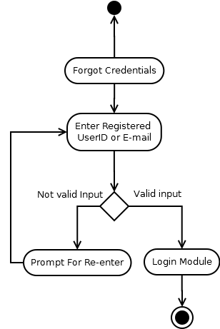

Generate Costing

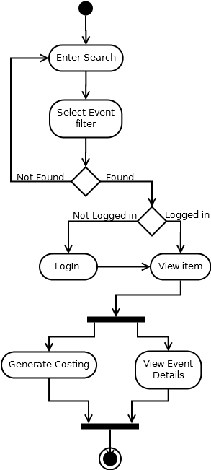

Search

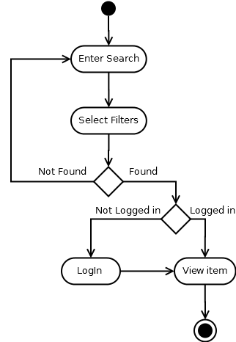

Send Mail

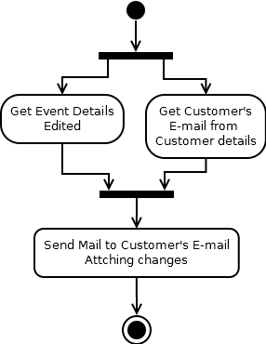

ER-diagrams :

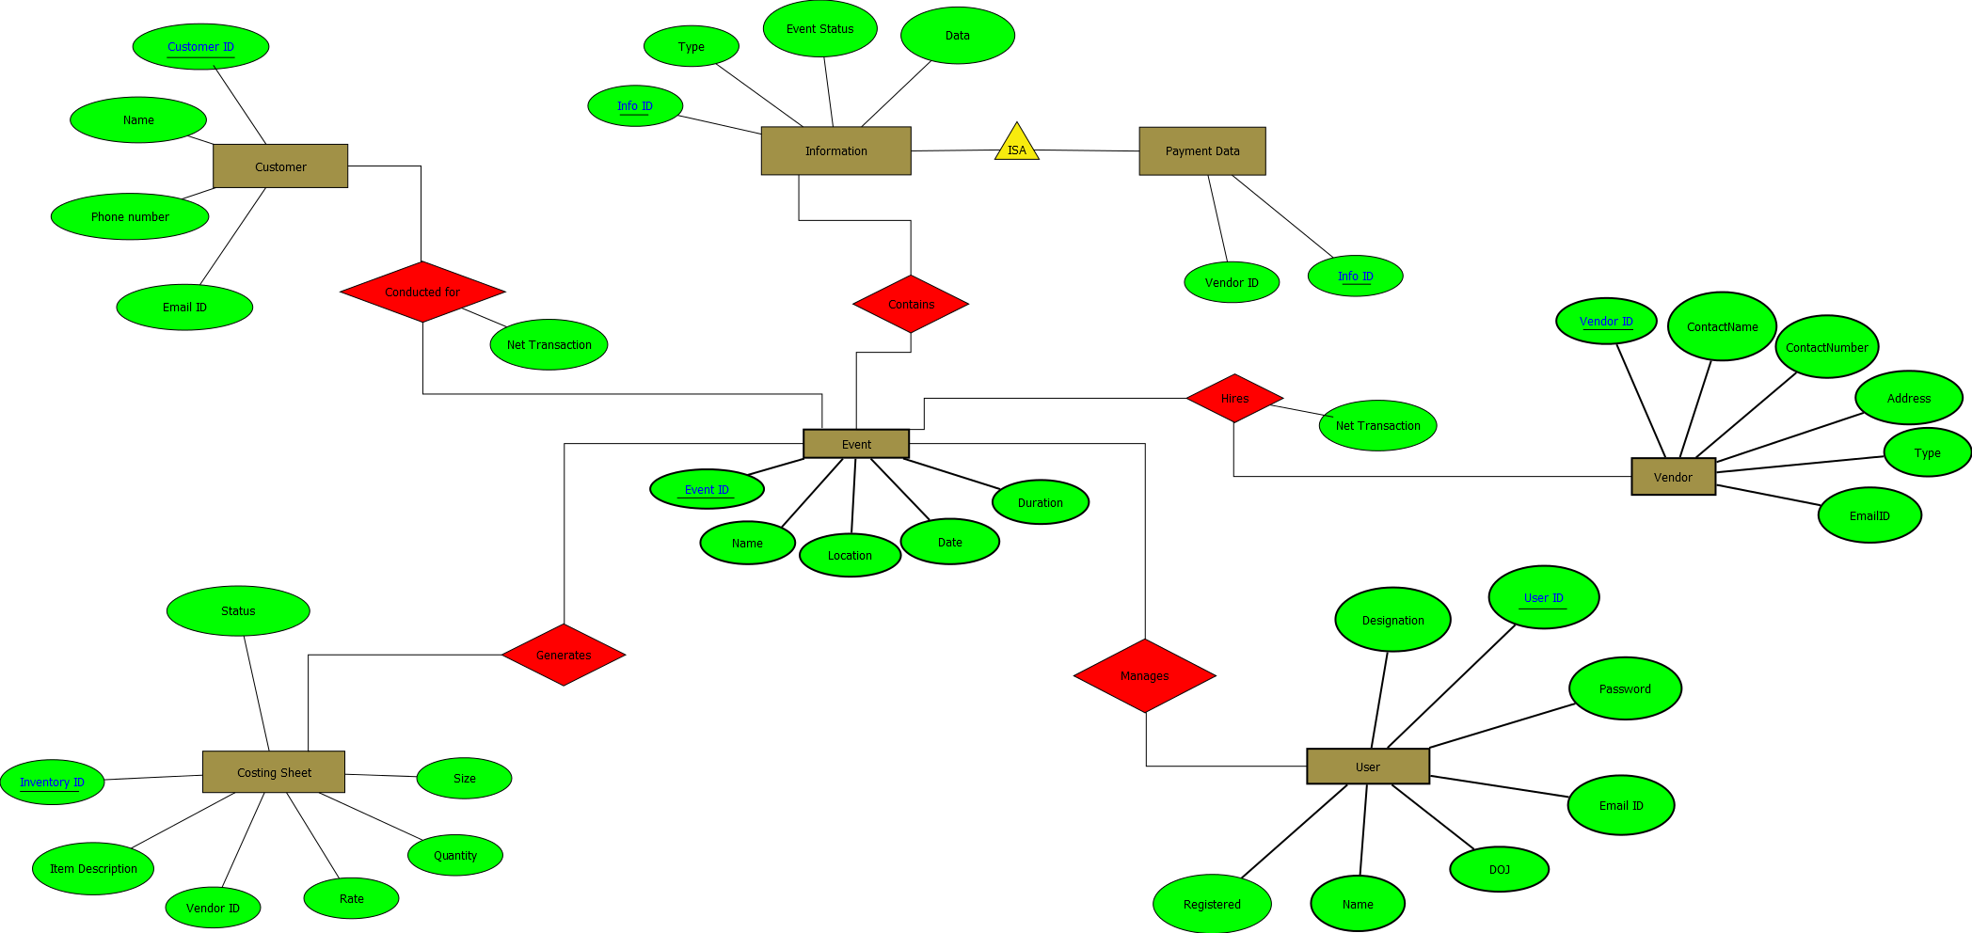

Data Dictionary

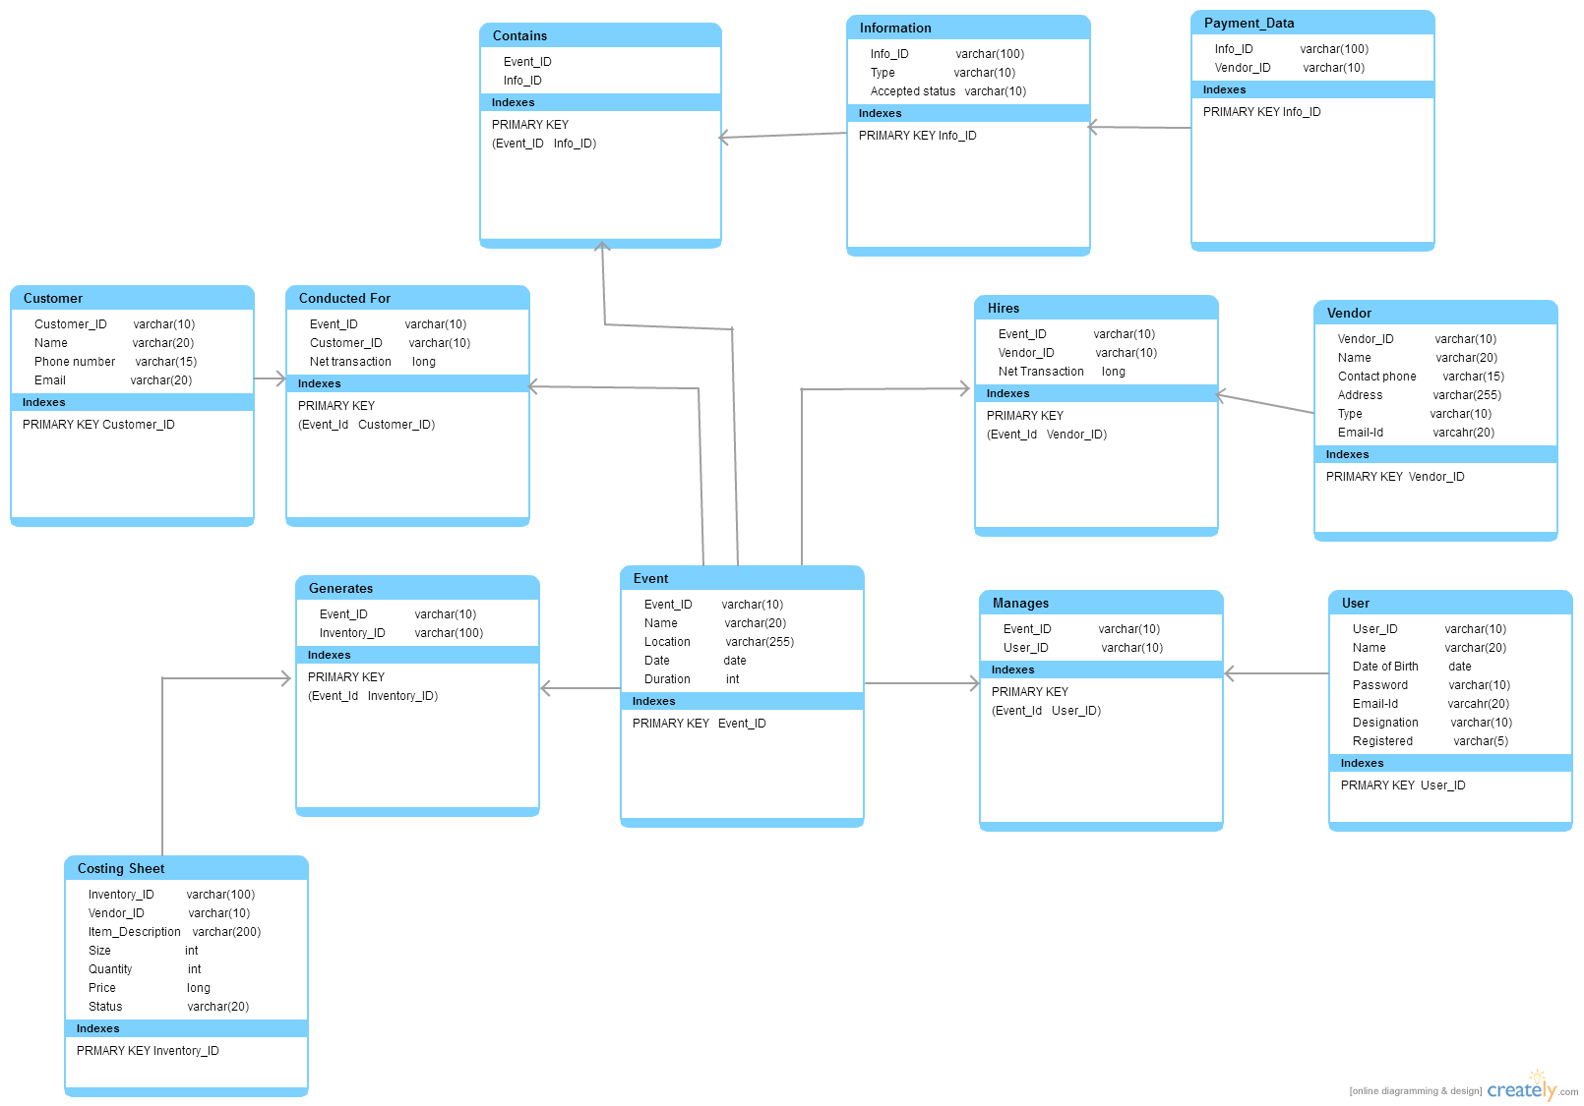

Data Flow Diagrams (DFD)

Data Flow Diagram is graphical representation of flow of data in an information system.It is capable of depicting incoming data flow,outgoing data flow and stored data.The DFD does not mention anything about how data flows through the system.

Data Flow Diagrams are of two types Logical or Physical

Logical DFD:

This type of DFD concentrates on the system process, and flow of data in the system

Physical DFD:

This type of DFD shows how the data flow is actually implemented in the system.It is more specific and close to the implementation.

Levels of DFD:

Level 0: Highest abstraction level DFD is known as Level 0 DFD,which depicts the entire information system as one diagram concealing all the underlying details.

Level 1: The Level 0 DFD is broken down into more specific,Level 1 DFD.Level 1 DFD depicts basic modules in the system and flow of data among various modules.

These two levels are sufficient for our project because every module can be clearly designed with in Level 1 phase.If we go one step it is like detailing in great detail but is not necessary because we will get whole idea of the module in Level 1.

Level 0 :

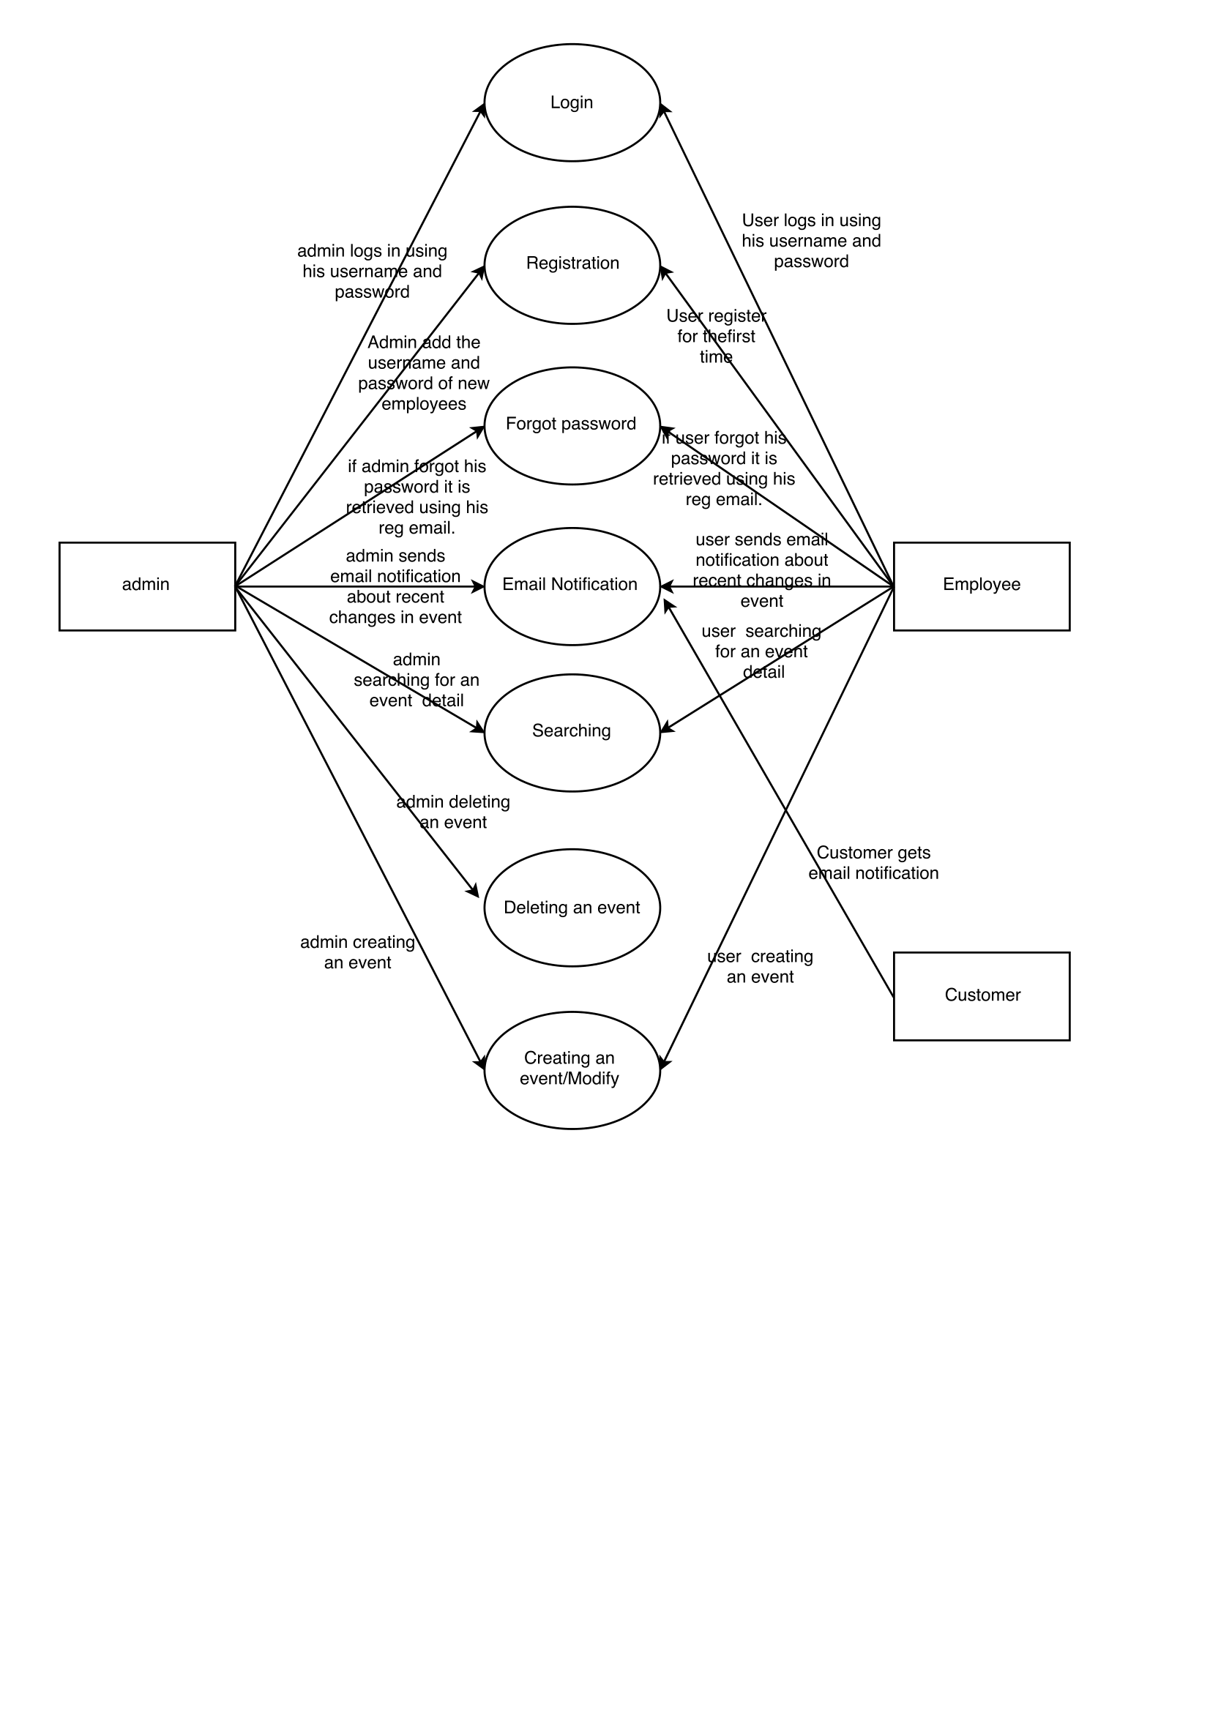

Level 1 :

Login

login.png

Registration

registration.png

Forgot Password

forgot_password.png

Searching an Event

searching.png

Event Creation

event creation.png

Email Notification

email_notification.png

Deleting an Event

deleting an event.png

**Sequence Diagram :**

UML sequence diagram model the flow of logic within your system in a visual manner,enabling you both to document and validate your logic, and we commonly used for both analysis and design purposes.Sequence Diagram are the most useful artifact for dynamic modeling which focuses on identifying the behaviour with our system.Sequence Diagrams are typically used to model Usage Scenarios,The logic of methods,The logic of services.

**1). Registration**

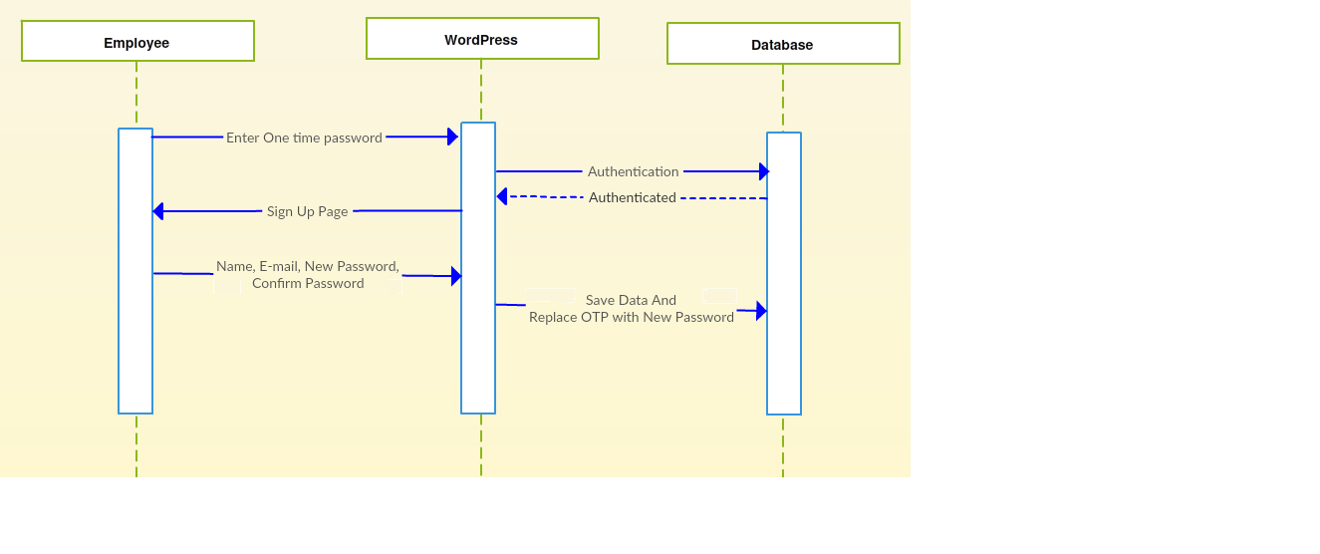

**2). Login**

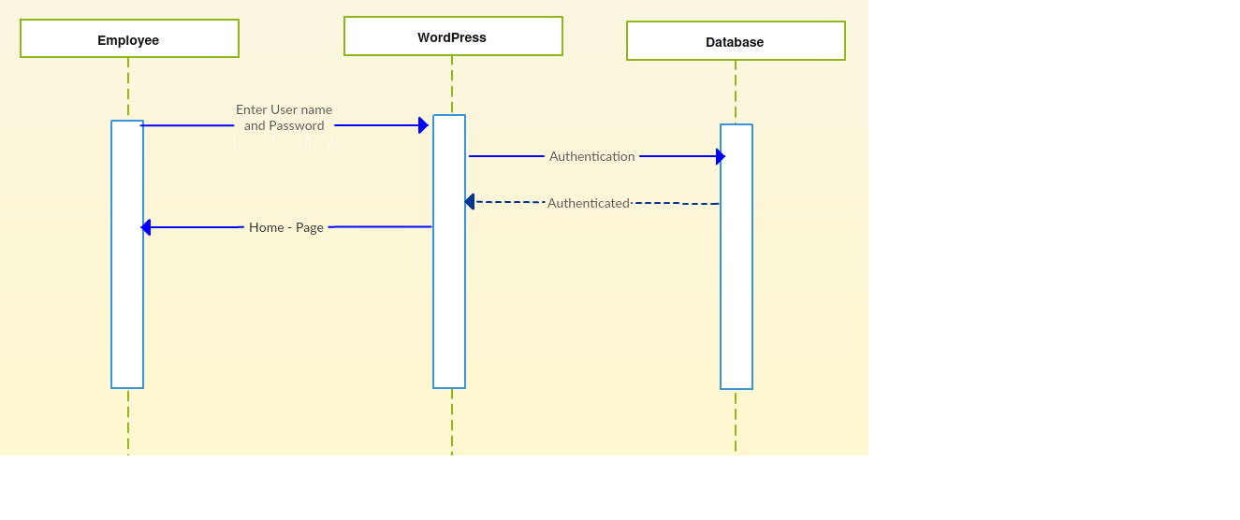

**3). Change Password**

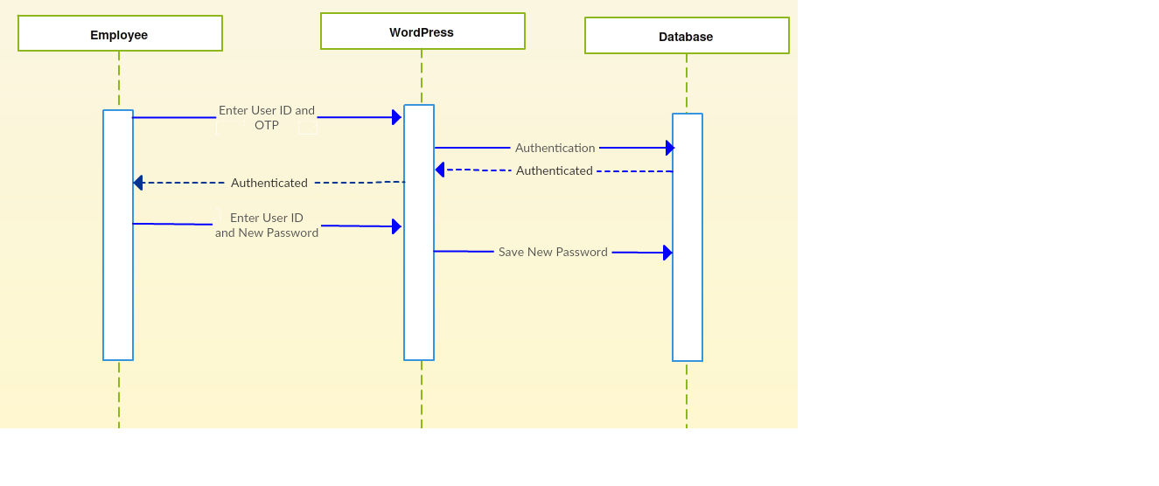

**4). Create Event**

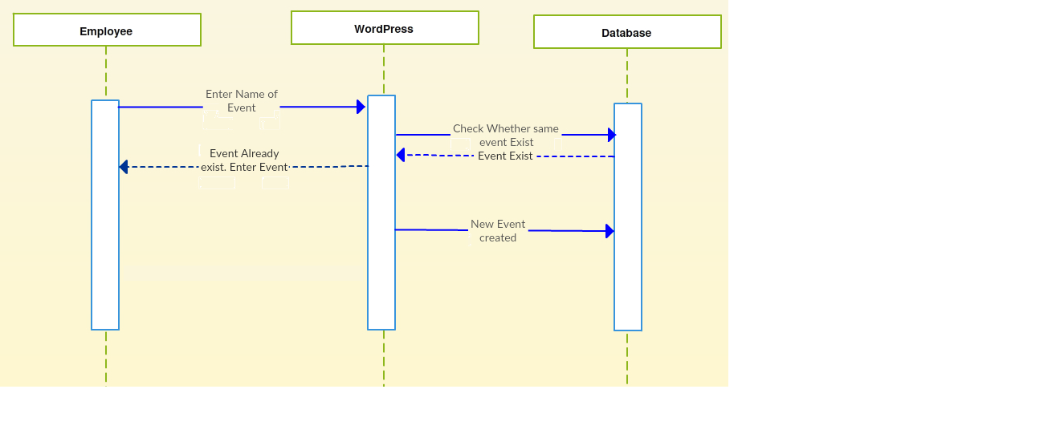

**5). Event Details**

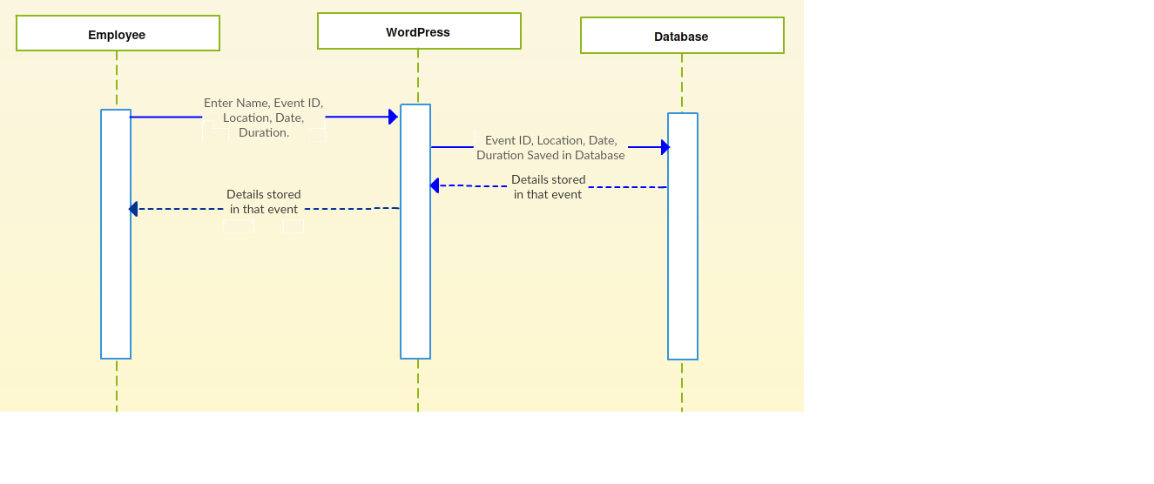

**6). Name Search**

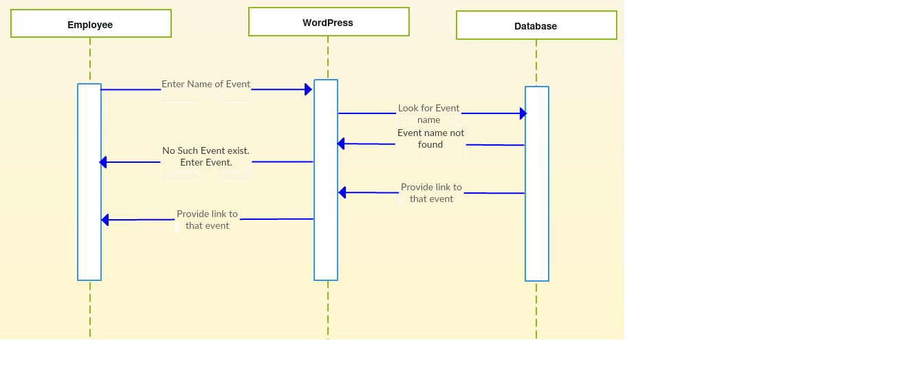

**7). Date Search**

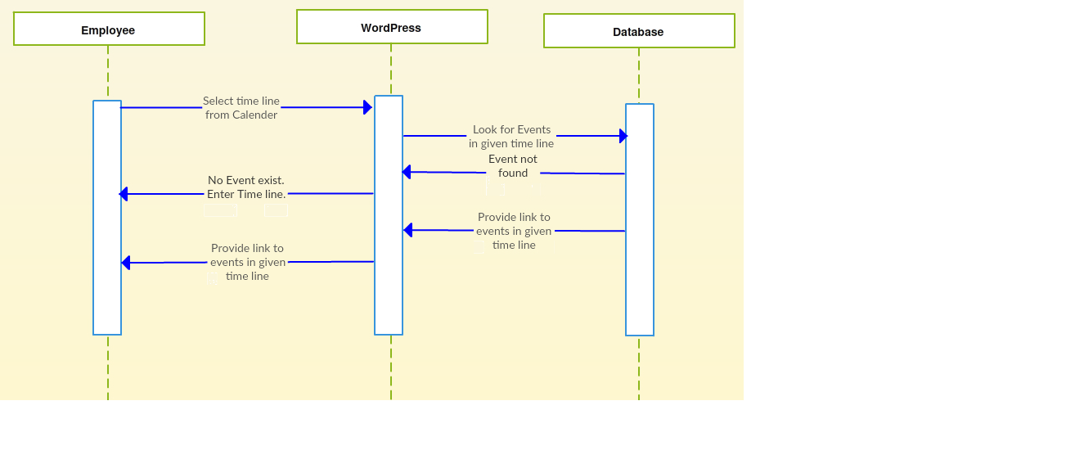

**8). Budget Search**

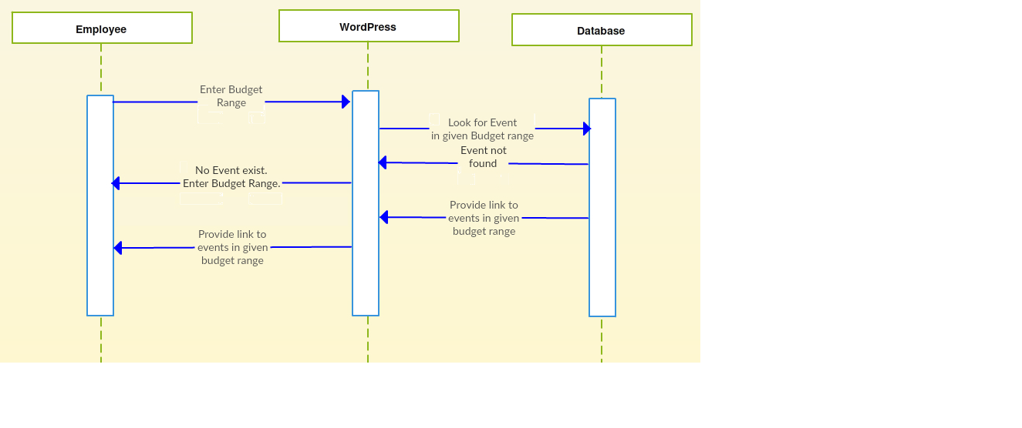

**9). Location Search**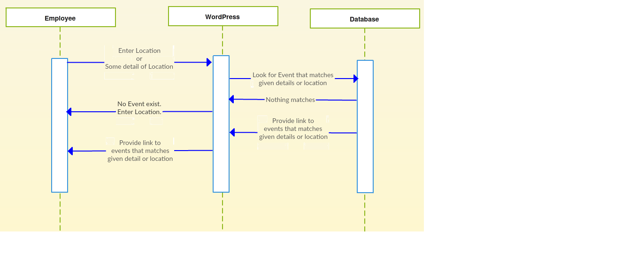

**10). Vendor Search**

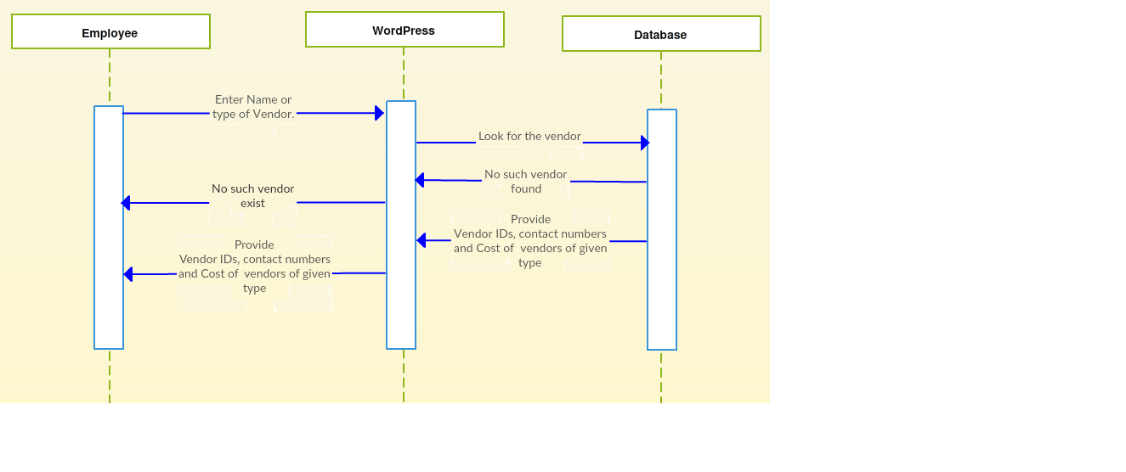

**11). Pitching Details**

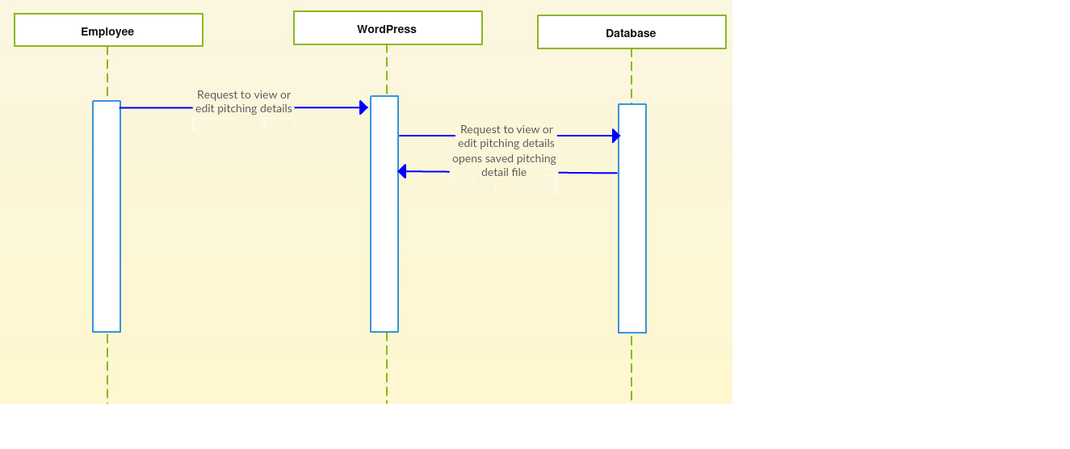

**12). Event Elements**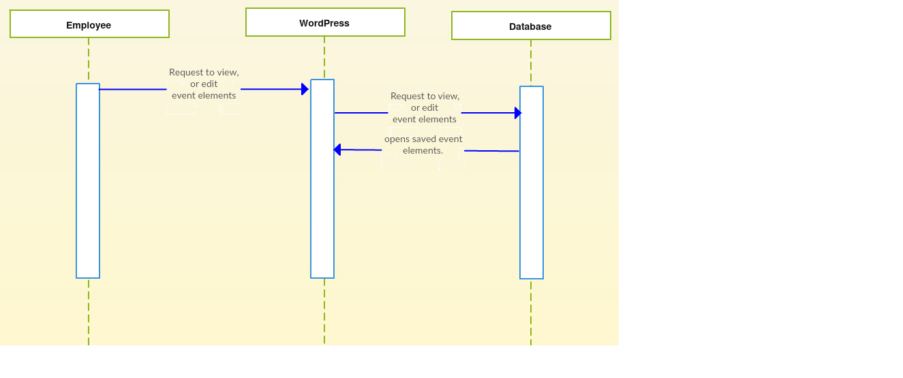**13). Generate cost Estimation**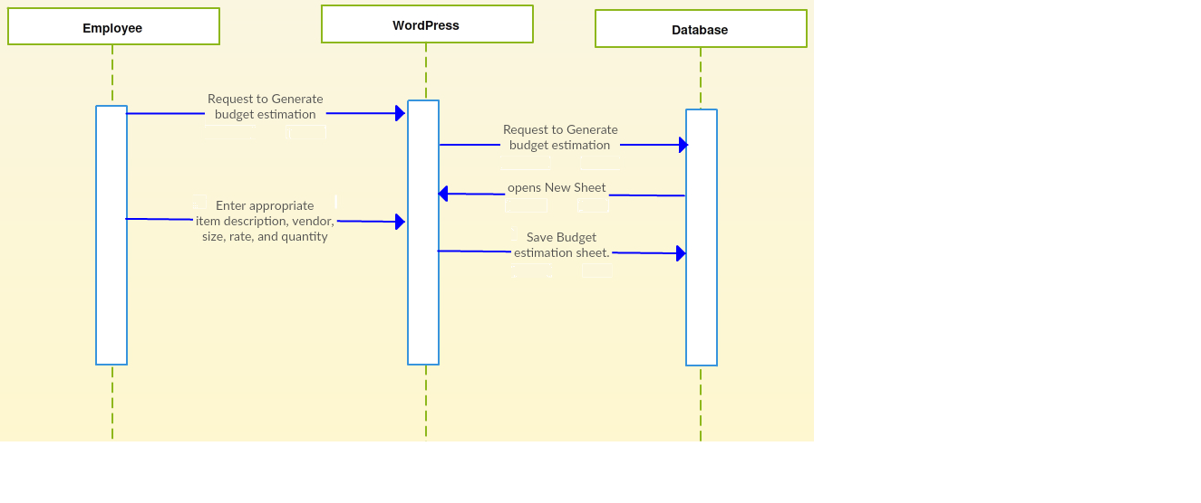

**14). Notificatio**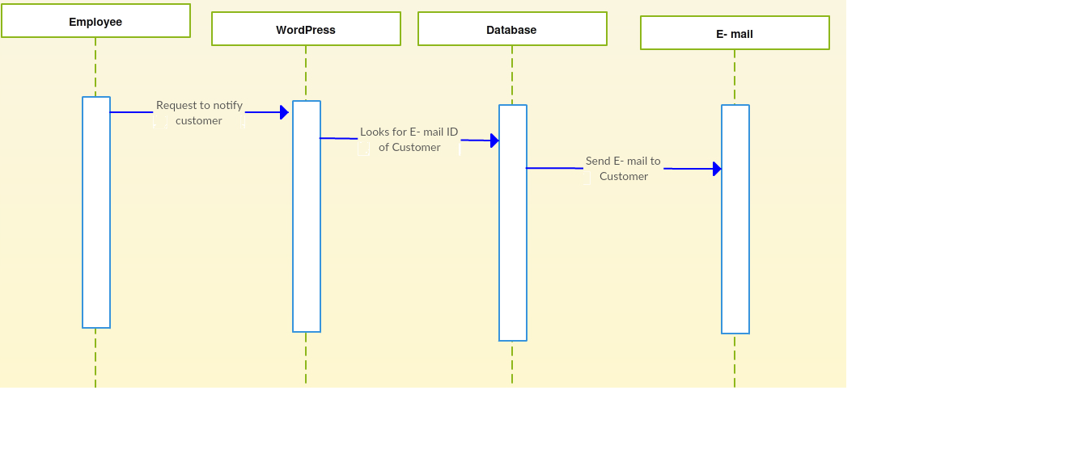

**15). Cost Generation**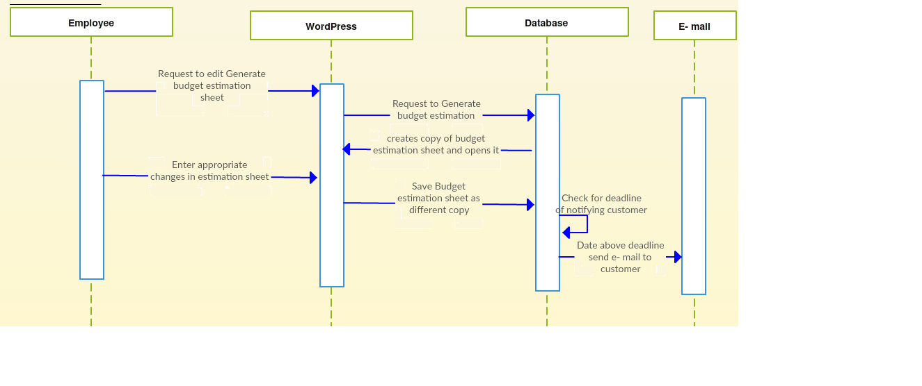

**Module Description** :

**Login Module** :

The login module helps the user to login into site and access all the functionalities of the website.If he enters wrong credentials he will be prompted with wrong username or password.

**Registration :**

The user will be given a username and password by the organisation he enters the credentials where he will be redirected to registration page.If he enters wrong credentials he will be in the same page.

**Forgot Password :**

An email consisting of new random password will be sent to the registered email thereby he can re login to the site.

**Event Search :**

A User can search a particular event based on the event name,location,date,budget and event date.

**Email-Notification :**

An email can be sent to the customer regarding the changes they are going to be done for a particular event apart from the customer requirements.If he approves this then only organisation will continue with the change.

**Create/ Delete/ Modify Event :**

An user can create an event at any time and he modify the existing event at any time the power for deletion a particular event lies with the admin only.As a part of creating an event he will also generate costing sheet for the event.